Hard Rock Mining
Lab Activity

This activity supports the following science content performance standards:
4th Grade | 4th Grade
4-ESS-3.2 Generate and compare multiple solutions to reduce the impacts of natural Earth processes on humans. | 4-ESS-3.1 Obtain and combine information to describe that energy and fuels are derived from natural resources and their uses affect the environment.

Mining is the process of extracting useful material from the earth. This often has a significant impact on the surrounding land. Our priority as responsible miners is to extract the material with as little damage to the land as possible.

Materials:
- Hard Chips Ahoy Chocolate Chip Cookies
- Soft Chips Ahoy Chocolate Chip Cookies
- Toothpicks
- Wood skewers

Activity:
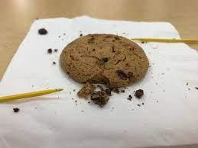
Students will choose either a hard chocolate chip cookie or a soft chocolate chip cookie. A variety of tools will be provided. The goal is to remove the chocolate chips without disturbing the rest of the cookie.

