Core Drilling Simulation
Lab Activity

This activity supports the following science content performance standards:
4th Grade
4-ESS-1.1 Identify evidence from patterns in rock formations and fossils in rock layers for changes in a landscape over time to support an explanation for changes in a landscape over time.

Core drilling is the most commonly used method of obtaining information about the presence of minerals or precious metals, as well as rock formations. In mining, we use core drilling to help us learn where we should be mining.
Materials needed:
- Multi-layered cupcakes (1 per student)
- Clear Boba straws (1 per student)

Teacher Prep:
- Bake multi color cupcakes using three different colored cupcake batters (chocolate, vanilla and strawberry), following the directions on the box. A colored cupcake liner is recommended so students can’t see that the cupcakes have multiple layers
- Frosting is optional, but not required
Activity:
Students will simulate producing core samples and learn that the earth is made up of various substances and different layers. Each student will have 1 cupcake and 1 clear straw. After “drilling” into the cupcake, students will be able to see the layers of the sample in their straw.
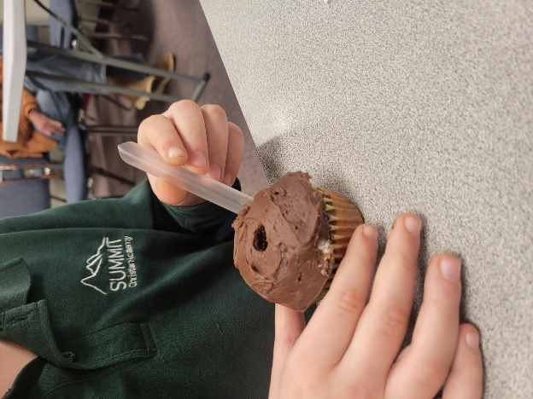
- Optional for 4th grade – Take three samples and try to predict what your 4th sample will look like.
