Modeling Geologic Core Samples
Lab Activity

This activity targets the following science content performance standards:
Middle School | High School
MS-ESS-3.1 Construct a scientific explanation based on evidence for how Earth’s mineral, energy, and groundwater resources are unevenly distributed as a result of past and current geologic processes. | HS-ESS-3.2 Evaluate competing design solutions for developing, managing, and utilizing energy and mineral resources based on cost-benefit ratios.

Materials:
- One multi-layered cupcake for each student (or each lab group)
- Clear straws (3 per cupcake)
- Napkins or paper towels
- Plastic knives
To make layered cupcakes:
Prepare a white cake mix recipe. Divide batter into several bowls and add various food colorings to each batch. Add small amounts of each colored batch to a paper liner in a cupcake pan, making sure that the top layer is a single color. Bake the cupcakes.
- Explain to students that they are geologists prospecting for valuable minerals. There are several ways to predict what layers might be present under the ground. Seismic (sound) waves can be used to make an “echogram” of the substrate. Other times geologists use coring devices to collect samples.

- Have students divide their cupcake into 4 sections by lightly scoring the top of their cupcake with the knife. Then they should choose 3 of the quadrants in which to take a core sample. Demonstrate how to insert the clear straw into the cupcake and remove it to view the layers inside the cupcake.
- Have students diagram and measure the length of each of the layers in their core samples. They should then predict what the inside of the cupcake would look like with a diagram.
- When students have finished their predictions, they can cut their cupcake open and see if their prediction was correct.

Modeling Geologic Core Samples

Procedure
- Lightly score the top of your cupcake with the knife with an X so that there are 4 quadrants.
- Choose 3 of the quadrants in which to take a core sample. Diagram the locations of your core samples in Figure 1.
- Draw a diagram of what each of your core samples look like, using colored pencils.
- Measure the length of each color in mm and record on your diagram.
- Make a prediction about what you think the inside of your cupcake looks like in each quadrant.
- The pink color represents a valuable resource that you would like to mine. In which quadrant would you choose to mine in order to make the most money?
- Cut your cupcake in half and observe each quadrant. Make a cross-section drawing of what your cupcake actually looks like on the interior.

- 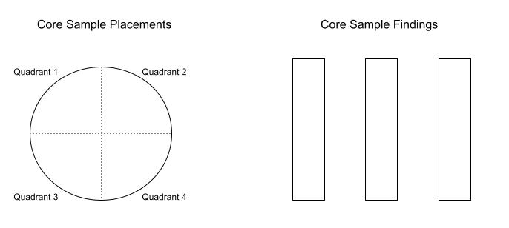
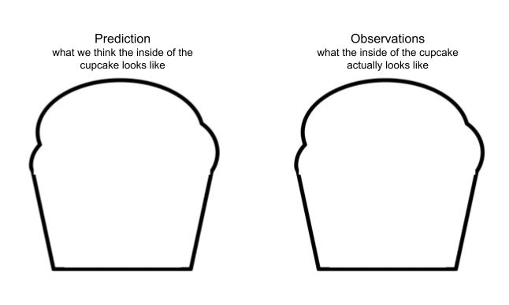
Conclusions:
- How did your assumptions about the cupcake change as the lab progressed?
  - Cupcake with no information

- Cupcake with partial information (only one core sample)

- Cupcake with more information (all core samples considered)

- Cupcake cut in half

- Compare and contrast the geology core sampling lab with real-world core sampling situations by describing 2 similarities and 2 differences.

