Flotation
Lab Demonstration

This activity supports the following science content performance standards:
4th Grade
4-ESS-3.1 Obtain and combine information to describe that energy and fuels are derived from natural resources and their uses affect the environment.

Flotation is used to separate valuable minerals from the rock and soil. Our responsibility as Metallurgists in the mining industry, is to learn what chemicals the minerals will stick to, to get them away from the rocks and dirt.
Materials:
• 3 cups of playground sand
• 2 tablespoons of glitter (large size)
• 8-oz small clear plastic cups (reusable)
• flexible straws
• paper plates
• 1 teaspoon of liquid dish soap per 1 cup water
• Paper towel or napkins for cleaning

Teacher Prep:
Combine the glitter and sand. Scoop 1 ½ tablespoons of glitter/sand mixture into the 8oz cup. Set aside. Mix soap and water in a pourable pitcher.
Activity:
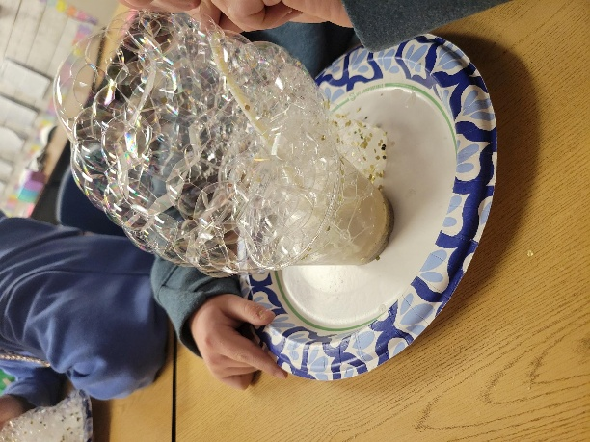
Set the cup with glittery sand on the paper plate. This simulates the ore that has been crushed and ground. Pour the soapy water over the sand until it covers the top about ½ inch. Blow bubbles into the mixture with the straw. Observe the glitter getting caught in the bubbles, while the sand remains in the cup. Continue blowing bubbles until a majority of the glitter is caught. The bubbles should take up the entire paper plate.

